Airbus Ship Detection Challenge

Bazsó Sándor (FYKXN2, [sanyi12b@gmail.com](mailto:sanyi12b@gmail.com)), Fényes Balázs (CAU3ZN, [f.balazs96@gmail.com](mailto:f.balazs96@gmail.com))

*Abstract* — Our problem is from Kaggle (<https://www.kaggle.com/c/airbus-ship-detection>) We give a solution using the Single Shot Detector neural network to the problem of detecting ships in satellite images.

# INTRODUCTION

Airbus is excited to challenge Kagglers to build a model that detects all ships in satellite images as quickly as possible. Can you find them even in imagery with clouds or haze?

Here’s the backstory: Shipping traffic is growing fast. More ships increase the chances of infractions at sea like environmentally devastating ship accidents, piracy, illegal fishing, drug trafficking, and illegal cargo movement. This has compelled many organizations, from environmental protection agencies to insurance companies and national government authorities, to have a closer watch over the open seas.

[*Airbus*](http://www.intelligence-airbusds.com/satellite-data/) offers comprehensive maritime monitoring services by building a meaningful solution for wide coverage, fine details, intensive monitoring, premium reactivity and interpretation response. Combining its proprietary-data with highly-trained analysts, they help to support the maritime industry to increase knowledge, anticipate threats, trigger alerts, and improve efficiency at sea.

A lot of work has been done over the last 10 years to automatically extract objects from satellite images with significative results but no effective operational effects. Now Airbus is turning to Kagglers to increase the accuracy and speed of automatic ship detection.

# About the task

In this competition, you are required to locate ships in images, and put an aligned bounding box segment around the ships you locate. Many images do not contain ships, and those that do may contain multiple ships. Ships within and across images may differ in size (sometimes significantly) and be located in open sea, at docks, marinas, etc.

For this metric, object segments cannot overlap. There were a small percentage of images in both the Train and Test set that had slight overlap of object segments when ships were directly next to each other. Any segments overlaps were removed by setting them to background (i.e., non-ship) encoding. Therefore, some images have a ground truth may be an aligned bounding box with some pixels removed from an edge of the segment. These small adjustments will have a minimal impact on scoring, since the scoring evaluates over increasing overlap thresholds.

# About the dataset

About 200000 satellite images are available together with the bounding boxes of the ships on the images. Each image has a dimension of 768 by 768 pixels, and has 3 (RGB) color channels. The majority of images contain no ships. Around half of the images which contains any ships have some kind of land in the image, i.e. a port. A few images only contain the landscape and no open water. There are many clouds obstructing the water surface. To make the task even more difficult the ships are varying widely in size. For example there are images about large freighters and small boats.

# Choosing the network

The following architectures were considered:

* R-CNN (Regions with CNN features): proposes rectangular regions and then classifies them, but is very slow (having a speed of around 1 minute/image)
* YOLO (You Only Look Once): creates an N×N grid of the image, and predicts the most likely class for each area (fast, but have a low spatial resolution)
* SSD (Single Shot Detector): similar to YOLO, but uses different sized grids and the bounding box need not be a square.

# About the single shot detector

From the original paper:

*SSD, discretizes the output space of bounding boxes into a set of default boxes over different aspect ratios and scales per feature map location. At prediction time, the network generates scores for the presence of each object category in each default box and produces adjustments to the box to better match the object shape. Additionally, the network combines predictions from multiple feature maps with different resolutions to naturally handle objects of various sizes*

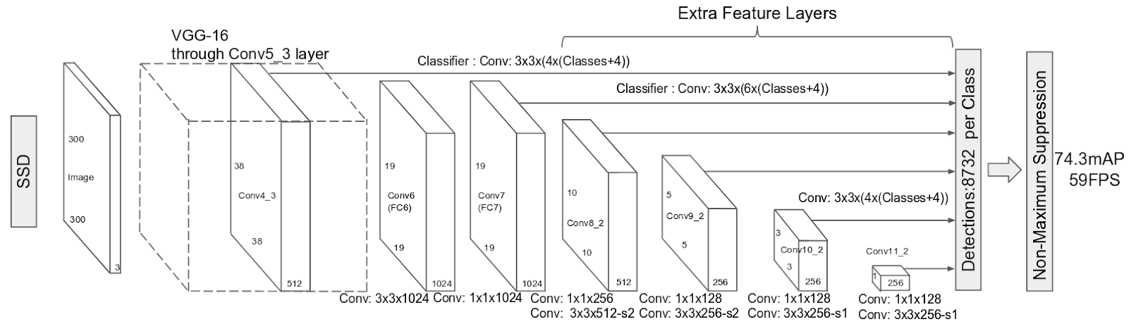

Description of how this network works: (source: <https://leonardoaraujosantos.gitbooks.io/artificial-inteligence/content/single-shot-detectors.html>)

*Summarising the strategy of these methods*

1. *Train a CNN with regression(bounding box) and classification objective (loss function).*
2. *Normally their loss functions are more complex because it has to manage multiple objectives (classification, regression, check if there is an object or not)*
3. *Gather Activation from a particular layer (or layers) to infer classification and location with a FC layer or another CONV layer that works like a FC layer.*
4. *During prediction use algorithms like non-maxima suppression to filter multiple boxes around same object.*
5. *During training time use algorithms like IoU to relate the predictions during training the the ground truth.*

*On this kind of detector it is typical to have a collection of boxes overlaid on the image at different spatial locations, scales and aspect ratios that act as “anchors” (sometimes called “priors” or “default boxes”).*

# Processing the data

The bounding boxes were provided in run-length encoding and we converted them to a format (coordinates) that can be understood by the network. An example of the original ground truth file:

"0570217ba.jpg, 555509 4 556273 8 557041 9 557809 4"

* The first element is the filename
* The second one is the run-length code. It contains pair of numbers in a sequence the first one is the starting pixel (the top left corner is 1), than going down and right. Second number is the run length from the starting position.
* There is at least one line for every image, with empty second value for shipless images
* And each line represents only one ship therefor it contains multiple line for images containing multiple ships

The *annotation/create_annotations.ipynb* notebook generates the bounding boxes from the given run-length encoding masks.

# Training the network

We used an implementation of the SSD made for the Keras framework. Source: <https://github.com/pierluigiferrari/ssd_keras>

The codes had to be modified (e.g. changing directory paths).

To save time on the training, we used a pretrained network, which has been trained on 300×300 images on the COCO image database. The pretrained weights are available in the ssd_keras github repository.  We used Google Cloud to run the training, which took about 1 day on a NVIDIA Tesla K80 GPU.

Since the MS COCO was originally trained on a dataset with 80 classes and we only had 1 class we had to downsample the weights. The SSD Keras framework contained a tutorial for this task and following that it was straight forward to do the downsampling. The code can be found in the *weight_sampling/weight_sampling.py* file.

Another difficulty we had to face came from the amount and size of the images. In the Kaggle dataset there are roughly 192 thousand images each with 768x768 resolution and 3 channels (RGB). In jpeg encoding they take nearly 30GB space but in order to process them they have to fit as uncompressed data into preferably the GPU memory or if it is not possible into the RAM. A quick calculation about the size:

$$192000*\left(768*768*3\right)=316GB$$

Even if we take into consideration fact that only 1/3 of the images contains ship it is still 100 GB data to fit into memory. (We can only train the SSD with images that contains at least one object.) One solution would be to resize the images to smaller size but in this case we would lost the tiny boats in this early state.

To overcame this we decided to crop the images around the ships. In order to do this we have 2 options:

1. Crop based on the ground truth data
2. Use an object detection algorithm to find any objects on the images and decide which contains ship based on the annotation

Some details about the second option: It is based on the fact that the ships are usually on the blue homogen sea and therefor most of the edges on the image are between ships and sea. (Of course this method has some limitation when the water is wavy.)

A block diagram about the algorithm:



An example of these steps:

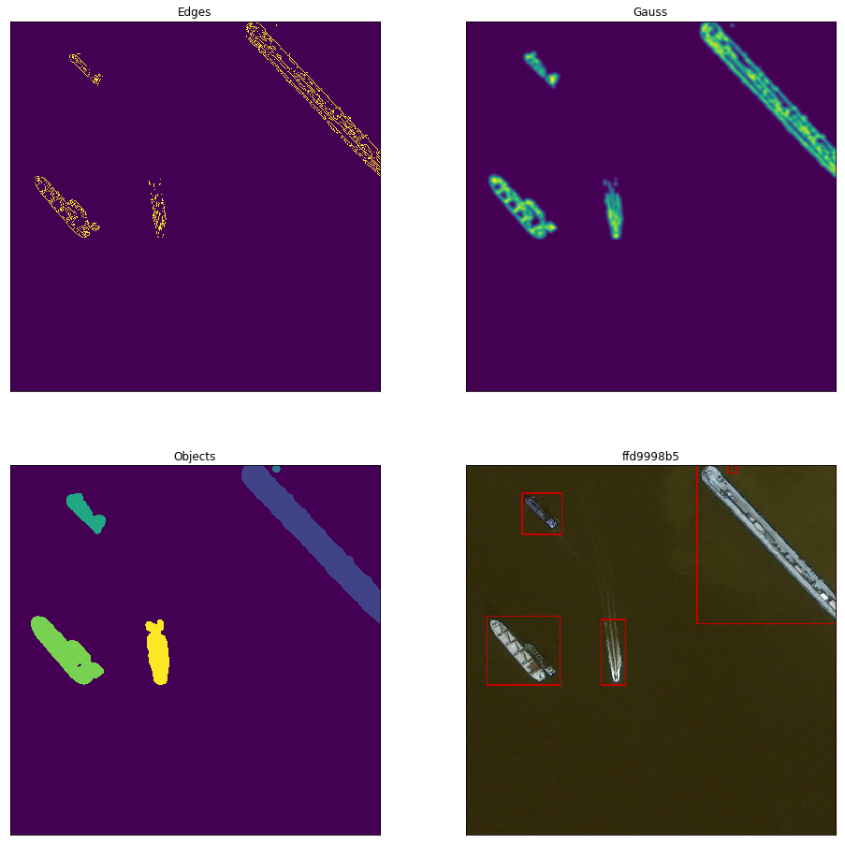

More information and examples about this algorithm can be found in the *cropimages/ObjectDetection.ipynb*.

We tried different parameters for the training but most of them performed very similarly. In each case we used transfer learning from MS COCO. The differences are summarized in the table below.

|  |  |  |  |  |
| --- | --- | --- | --- | --- |
|  | 2. | 3. | 5. | 6. |
| Image | Cropped (2) | Cropped (2) | Cropped (2) | Cropped (1) |
| Optimizer | Adam | Adam | Sgd | Adam |
| Batch_size | 8 | 8 | 8 | 32 |
| Frozen layers | None | 0-22 | 0-14 | None |

In the Image line *Cropped (1)* means we cropped based on the ground truth and *Cropped (2)* was cropped with the algorithm presented above. When we set layers from 0-22 to not trainable the network stopped training after 50 epochs. With layers from 0 to 14 being frozen the results are better, but it still lack behind the 2. option.

To summarize the training here is the workflow:



The best model is included at: *weights/ShipDetection-120_loss-2.8902_val_loss-2.7863.h5*

In theory this method can have problems due to the network only trains on images about ships and no landscape or port (we cropped those parts out from the images). But we rarely encountered that kind of issue at the evaluation.

An example training script is located at: *training/training.py*, an example log is located at: *training/train_log.csv*

# Evaluating the results

The network detects only large ships, and may detect islands as ships. Our network only works for images of size 300×300 (this restriction is coming from the MS COCO model, because it was trained on 300x300 images), therefore the satellite images had to be resized before giving it to the network. If a ship is small, then it will be even smaller and the network will not detect it. To solve this problem, we decided to cut the images into a few overlapping 300×300 images and then combine the predictions.

An example image (size: 768×768):

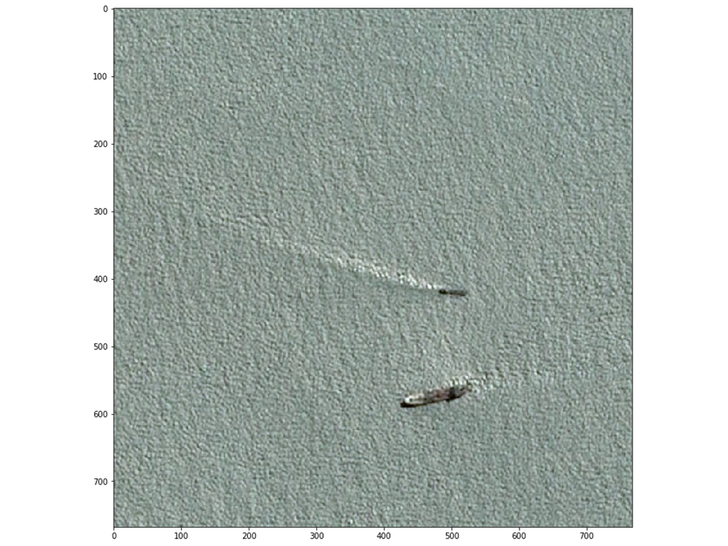

Predicted objects (image resized to 300×300):

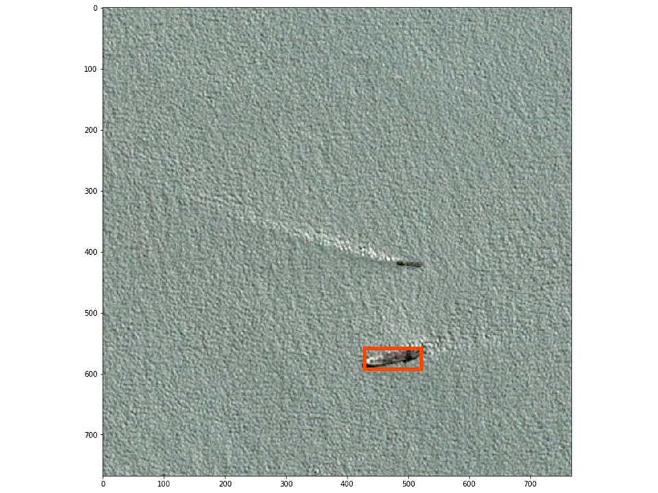

Segment image to avoid loss of small features due to resizing:

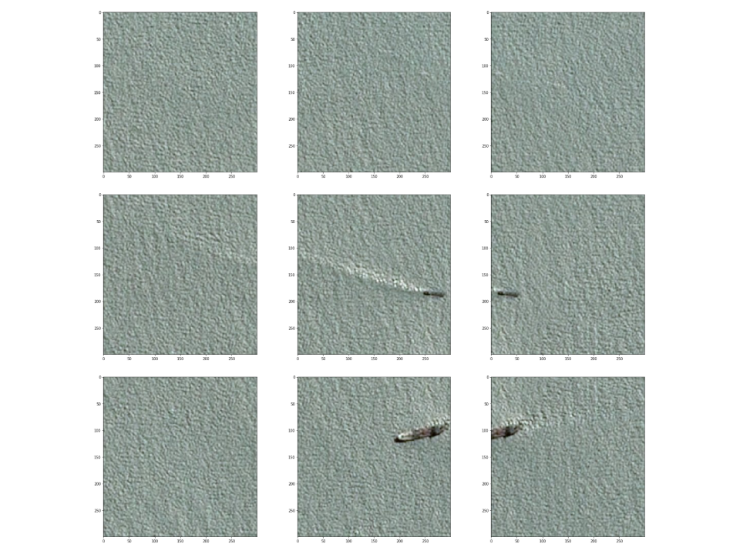

Prediction on the smaller segments is more successful:

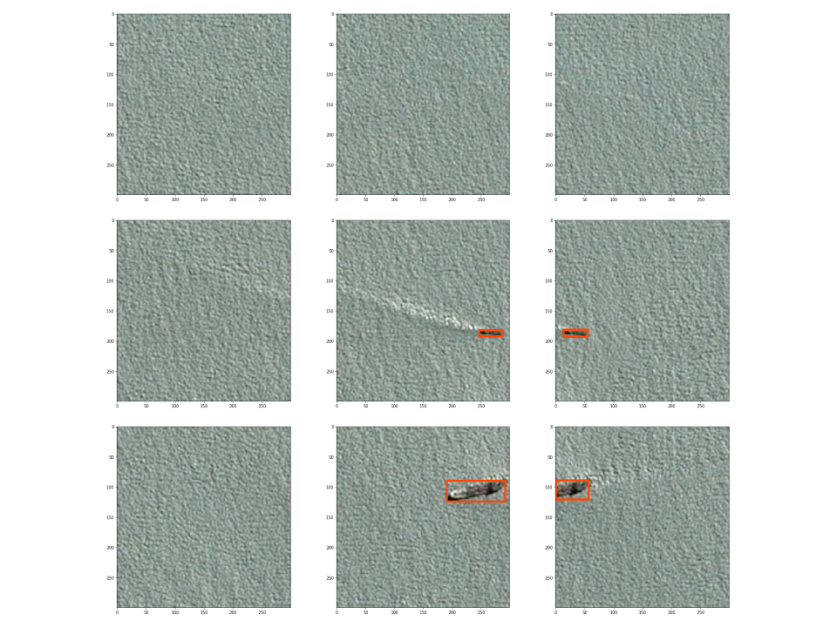

Display predictions on the original image:

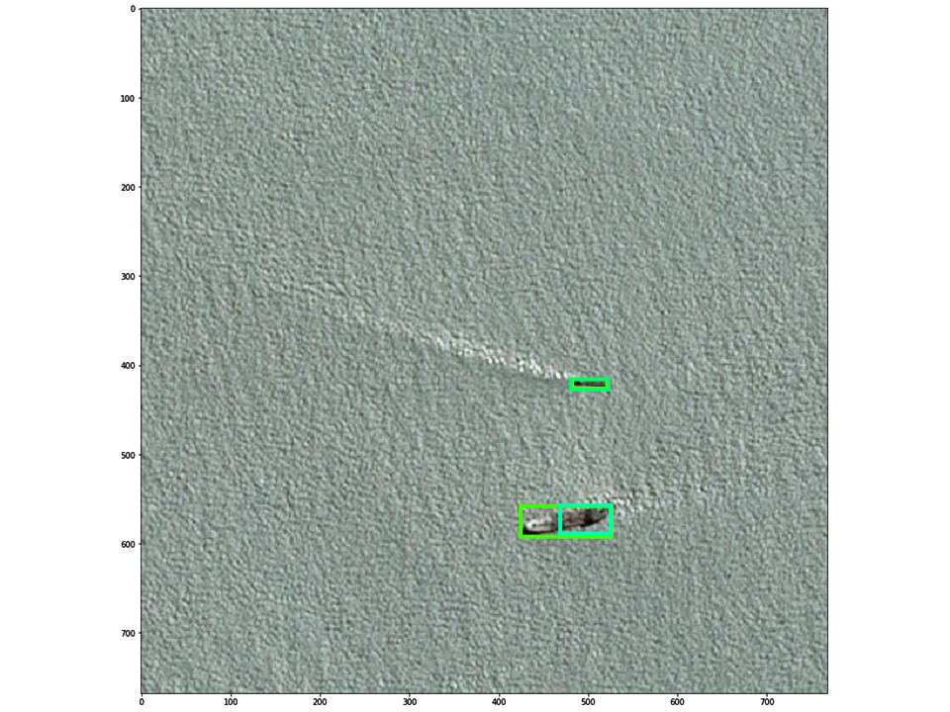

Combine overlapping predictions:

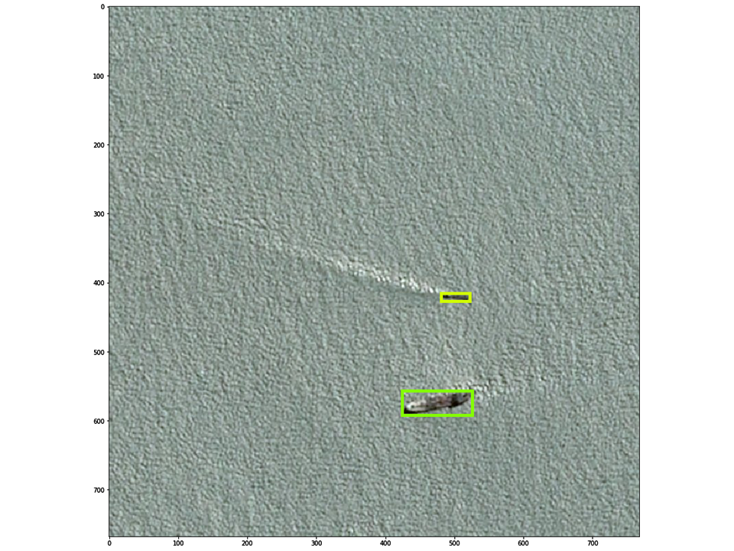

# Comparison with other solutions

The main drawback of our model is that it can only predict rectangular areas, while the competition scoring is depends on the correctly predicted pixels of the ships. The most successful teams used the U-Net network, which is a fully convolutional neural network with residual (skip) connections.

The network also struggles with small ships.

# small ships detection

To overcame the difficulties with small ships we tried to detect them with a VGG16 network and the cropping algorithm we discussed above.

*VGG is a convolutional neural network model proposed by K. Simonyan and A. Zisserman from the University of Oxford in the paper “Very Deep Convolutional Networks for Large-Scale Image Recognition” . The model achieves 92.7% top-5 test accuracy in ImageNet , which is a dataset of over 14 million images belonging to 1000 classes.*

More details can be found at: <https://www.cs.toronto.edu/~frossard/post/vgg16/>



The training and evaluation scripts are in the *smallships/* folder. This method does not recognize objects, it categorize the whole image (in our case the cropped out part). Of course we had to resize the images and than make transformations at the evaluation.

**Evaluating the results**: Roughly 1/3 of the detected ships are already detected by the SSD. Another 1/3 of the detected ships are small boats (that was our goal). But the rests are false positive, which depending on the usecase of the network can be too much. Although it picked up some smaller ships put lots of them remained undetected. Due to that and the poor precision this method to increase the SSD’s precision is a failure.

References

[R-CNN] Ross Girshick, Jeff Donahue, Trevor Darrell, Jitendra Malik, *Rich feature hierarchies for accurate object detection and semantic segmentation*, UC Berkeley, 2013, <https://arxiv.org/pdf/1311.2524.pdf>

[YOLO] Joseph Redmon, Santosh Divvala, Ross Girshick, Ali Farhadi, *You Only Look Once: Unified, Real-Time Object* DetectionW.-K. Chen, *Linear Networks and Systems*, University of Washington, Allen Institute for AI, Facebook AI Research, 2015, <https://arxiv.org/pdf/1506.02640v5.pdf>

[SSD] Wei Liu, Dragomir Anguelov, Dumitru Erhan, Christian Szegedy, Scott Reed, Cheng-Yang Fu, Alexander C. Berg, *SSD: Single Shot MultiBox Detector*, UNC Chapel Hill, Zoox Inc., Google Inc., University of Michigan, Ann-Arbor, 2015, <https://arxiv.org/pdf/1512.02325.pdf>

[U-Net] Olaf Ronneberger, Philipp Fischer, Thomas Brox, *U-Net: Convolutional Networks for Biomedical Image Segmentation*, Computer Science Department and BIOSS Centre for Biological Signalling Studies, University of Freiburg, Germany, 2015, <https://arxiv.org/pdf/1505.04597.pdf>

[VGG] Karen Simonyan, Andrew Zisserman: Very Deep Convolutional Networks for Large-Scale Image Recognition, Visual Geometry Group, Department of Engineering Science, University of Oxford, UK, 2014 <https://arxiv.org/abs/1409.1556v6>

Szegedy, C., Reed, S., Erhan, D., Anguelov, D.: Scalable, high-quality object detection, Google Inc., 1600 Amphitheatre Pkwy, Mountain View, CA, 2014, <https://arxiv.org/abs/1412.1441v3>

Karanbir Chahal, Kuntal Dey, A Survey of Modern Object Detection Literature using Deep Learning, 2018, <https://arxiv.org/abs/1808.07256>

Howard, A.G.: Some improvements on deep convolutional neural network based image classification, Andrew Howard Consulting Ventura, CA 93003, 2013, <https://arxiv.org/abs/1312.5402v1>

J. Donahue, Y. Jia, O. Vinyals, J. Hoffman, N. Zhang, E. Tzeng, and T. Darrell. Decaf: A deep convolutional activation feature for generic visual recognition, UC Berkeley & ICSI, Berkeley, CA, USA, 2013, <https://arxiv.org/abs/1310.1531>

S. Ren, K. He, R. Girshick, and J. Sun. Faster r-cnn: Towards real-time object detection with region proposal networks, 2015, <https://arxiv.org/abs/1506.01497v3>

Examples

More examples are included in the *evaluation/* directory and *smallships/smallships_evaluation.ipynb* where green represents the ground truth, red for the SSD and purple for VGG.

